EC-467 Mobile Application Development

BS (CE)-2021 LAB REPORT #3

Submitted By:

Reg. No. | Name
21-CE-009 | Huzaifa Shahbaz

Department of Computer Engineering
HITEC University Taxila
 | Presentation (Format(0.5)+ Title (0.5)+ Conclusion(1)  +Procedure(2)  +Objective(1)) | Calculation/ Coding | Observation/ Program Results | Total
Total | 5 | 5 | 5 | 15
Obtained

Lab Instructor. Dr. Muhammad Bilal
LAB REPORT #3
Activity with GUI and Layout
Activity with GUI and Layout: Creating an activity with a graphical user interface (GUI) and implementing a layout is a fundamental aspect of software development, especially in the realm of mobile applications. Whether you're developing for Android, iOS, or another platform, designing an intuitive and visually appealing interface is crucial for providing a seamless user experience. The following steps: 1.Setting up a new Android project in Android Studio. 2.Creating a new activity with a GUI layout using XML. 3.Implementing a basic layout structure with various UI components such as TextViews, Buttons, EditTexts, etc. 4.Previewing the layout within Android Studio's design editor. 5.Running the application on an emulator or physical device to test the GUI functionality.
Class Task: Make a tasbeeh app to implement the text View,reset,count,view history. Java CODE:
package com.huzaifashahbaz.tasbeehcounterapp;
import android.os.Bundle;
import android.view.View;
import android.widget.Button;
import android.widget.TextView;
import android.widget.Toast;
import androidx.activity.EdgeToEdge;
import androidx.appcompat.app.AppCompatActivity;
import androidx.core.graphics.Insets;
import androidx.core.view.ViewCompat;
import androidx.core.view.WindowInsetsCompat;
public class MainActivity extends AppCompatActivity {
TextView tvCount;
Button btnCount,btnReset,btnViewHistory;
int Count=0;
@Override
protected void onCreate(Bundle savedInstanceState) {
super.onCreate(savedInstanceState);
setContentView(R.layout.activity_main);
tvCount=findViewById(R.id.text_view_count);
}
public void onPressResetbtn(View view)
{
Count=0;
tvCount.setText("Count:" + Count);
}
public void onPressHistorybtn(View view)
{
Toast.makeText(this, "JAZAKALLAJKHAIR", Toast.LENGTH_SHORT).show();
}
public void onPressCountbtn(View view)
{
Count++;
tvCount.setText("Count:"+Count);
}
}

XML CODE:
<?xml version="1.0" encoding="utf-8"?>
<LinearLayout xmlns:android="http://schemas.android.com/apk/res/android"
xmlns:app="http://schemas.android.com/apk/res-auto"
xmlns:tools="http://schemas.android.com/tools"
android:layout_width="match_parent"
android:layout_height_="match_parent"
android:gravity="center"
android:orientation="vertical"
tools:context=".MainActivity">
<TextView
android:id="@+id/textView"
android:layout_width="131dp"
</ android:layout_height="wrap_content"
android:text="TextView"
android:textColorLink="#805F5F"
tools:layout_editor_absoluteX="267dp"
tools:layout_editor_absoluteY="142dp" />
<LinearLayout
android:layout_width="match_parent"
android:layout_height="wrap_content"
android:orientation="horizontal">
<Button
android:id="@+id/btn_count_1"
android:layout_width="245dp"
android:layout_height="wrap_content"
android:onClick="onPressCountBtn"
android:text="Count"
tools:layout_editor_absoluteX="198dp"
tools:layout_editor_absoluteY="156dp" />
<Button
android:id="@+id/btn_Rest_1"
android:layout_width="142dp"
android:layout_height="wrap_content"
android:onClick="onPressResetBtn"
android:text="Reset"
tools:layout_editor_absoluteX="247dp"
tools:layout_editor_absoluteY="224dp" />
</LinearLayout>
<Button
android:id="@+id/btnViewhistory"
android:layout_width="match_parent"
android:layout_height="wrap_content"
android:onClick="onPressHistorybtn"
android:text="View history"
tools:layout_editor_absoluteX="296dp"
tools:layout_editor_absoluteY="153dp" />
</LinearLayout>
Results:
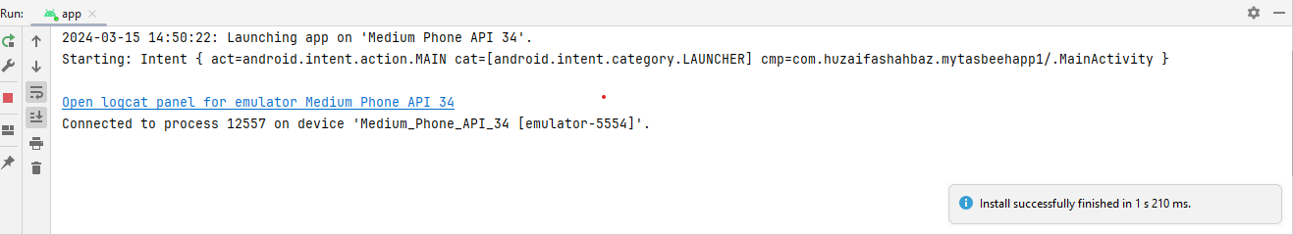
Output:
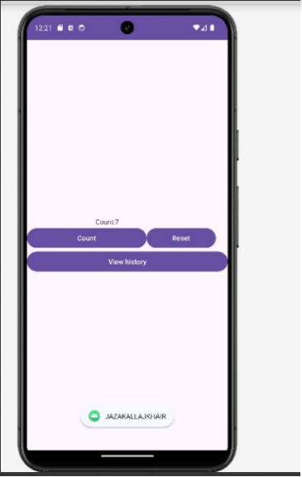

HOME TASK: Design the following. 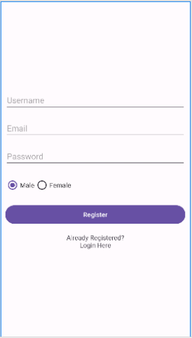
XML CODE: <LinearLayout
xmlns:android="http://schemas.android.com/apk/res/android"
android:layout_width="match_parent"
android:layout_height="match_parent"
android:orientation="vertical"
android:padding="16dp">
<EditText
android:id="@+id/usernameEditText"
android:layout_width="match_parent"
android:layout_height="wrap_content"
android:hint="Username"
android:minHeight="48dp" />
<EditText
android:id="@+id/emailEditText"
android:layout_width="match_parent"
android:layout_height="wrap_content"
android:hint="Email"
android:inputType="textEmailAddress"
android:minHeight="48dp" />
<EditText
android:id="@+id/passwordEditText"
android:layout_width="match_parent"
android:layout_height="wrap_content"
android:hint="Password"
android:inputType="textPassword"
android:minHeight="48dp" />
<RadioGroup
android:id="@+id/genderRadioGroup"
android:layout_width="wrap_content"
android:layout_height="wrap_content"
android:orientation="horizontal"
android:onClick="onPressRadioGroupbtn">
<RadioButton
android:id="@+id/maleRadioButton"
android:layout_width="wrap_content"
android:layout_height="wrap_content"
android:onClick="onPressMalebtn"
android:text="Male" />
<RadioButton
android:id="@+id/femaleRadioButton"
android:layout_width="wrap_content"
android:layout_height="wrap_content"
android:onClick="onPressFemalebtn"
android:text="Female" />
</RadioGroup>
<Button
android:id="@+id/registerButton"
android:layout_width="wrap_content"
android:layout_height="wrap_content"
android:layout_gravity="center_horizontal"
android:onClick="onPressRegisterbtn"
android:text="Register" />
<TextView
android:id="@+id/alreadyRegisteredTextView"
android:layout_width="wrap_content"
android:layout_height="wrap_content"
android:layout_gravity="center_horizontal"
android:text="Already Registered?" />
<Button
android:id="@+id/loginButton"
android:layout_width="wrap_content"
android:layout_height="wrap_content"
android:layout_gravity="center_horizontal"
android:onClick="onPressLoginHerebtn"
android:text="Login Here" />
</LinearLayout>
Java CODE: package com.huzaifashahbaz.madlab3;
public class RegistrationActivity extends AppCompatActivity {
private EditText mUsernameEditText;
private EditText mEmailEditText;
private EditText mPasswordEditText;
private RadioGroup mGenderRadioGroup;
private Button mRegisterButton;
private TextView mAlreadyRegisteredTextView;
@Override
protected void onCreate(Bundle savedInstanceState) {
super.onCreate(savedInstanceState);
setContentView(R.layout.activity_main);
mUsernameEditText = findViewById(R.id.usernameEditText);
mEmailEditText = findViewById(R.id.emailEditText);
mPasswordEditText = findViewById(R.id.passwordEditText);
mGenderRadioGroup = findViewById(R.id.genderRadioGroup);
mRegisterButton = findViewById(R.id.registerButton);
mAlreadyRegisteredTextView = findViewById(R.id.alreadyRegisteredTextView);
mRegisterButton.setOnClickListener(new View.OnClickListener() {
@Override
public void onClick(View view) {
String username = mUsernameEditText.getText().toString();
String email = mEmailEditText.getText().toString();
String password = mPasswordEditText.getText().toString();
int genderId = mGenderRadioGroup.getCheckedRadioButtonId();
RadioButton genderRadioButton = findViewById(genderId);
String gender = genderRadioButton.getText().toString();
// Validate form input
if (username.isEmpty() || email.isEmpty() || password.isEmpty() || gender.isEmpty()) {
Toast.makeText(RegistrationActivity.this, "Please fill out all fields", Toast.LENGTH_SHORT).show();
return;
}
// TODO: Send registration data to server or database
// Clear form input
mUsernameEditText.setText("");
mEmailEditText.setText("");
mPasswordEditText.setText("");
mGenderRadioGroup.clearCheck();
Toast.makeText(RegistrationActivity.this, "Registration successful!", Toast.LENGTH_SHORT).show();
}
});
mAlreadyRegisteredTextView.setOnClickListener(new View.OnClickListener() {
@Override
public void onClick(View view) {
// TODO: Navigate to login screen
}
});
}
}
public class RegistrationActivity extends AppCompatActivity {
private EditText mUsernameEditText;
private EditText mEmailEditText;
private EditText mPasswordEditText;
private RadioGroup mGenderRadioGroup;
private Button mRegisterButton;
private TextView mAlreadyRegisteredTextView;
@Override
protected void onCreate(Bundle savedInstanceState) {
super.onCreate(savedInstanceState);
setContentView(R.layout.activity_registration);
mUsernameEditText = findViewById(R.id.usernameEditText);
mEmailEditText = findViewById(R.id.emailEditText);
mPasswordEditText = findViewById(R.id.passwordEditText);
mGenderRadioGroup = findViewById(R.id.genderRadioGroup);
mRegisterButton = findViewById(R.id.registerButton);
mAlreadyRegisteredTextView = findViewById(R.id.alreadyRegisteredTextView);
mRegisterButton.setOnClickListener(new View.OnClickListener() {
@Override
public void onClick(View view) {
String username = mUsernameEditText.getText().toString();
String email = mEmailEditText.getText().toString();
String password = mPasswordEditText.getText().toString();
int genderId = mGenderRadioGroup.getCheckedRadioButtonId();
RadioButton genderRadioButton = findViewById(genderId);
String gender = genderRadioButton.getText().toString();
// Validate form input
if (username.isEmpty() || email.isEmpty() || password.isEmpty() || gender.isEmpty()) {
Toast.makeText(RegistrationActivity.this, "Please fill out all fields", Toast.LENGTH_SHORT).show();
return;
}
// TODO: Send registration data to server or database
// Clear form input
mUsernameEditText.setText("");
mEmailEditText.setText("");
mPasswordEditText.setText("");
mGenderRadioGroup.clearCheck();
Toast.makeText(RegistrationActivity.this, "Registration successful!", Toast.LENGTH_SHORT).show();
}
});
mAlreadyRegisteredTextView.setOnClickListener(new View.OnClickListener() {
@Override
public void onClick(View view) {
// TODO: Navigate to login screen
}
});
}
}

Results:

OUTPUT:

Conclusion: In conclusion, we had know how to make the tasbeeh counter app and registration form by performing java code and xml code(Linear Layout).Also we saw their working ,construction and functions in frontend and backend of the mobile app.

